Guide to the Key Financial Statements and Financial Reporting

- Financial Statements

- Group Accounts

- Profit and Loss / Income Statement

- Statement of Recognised Income and Expense

- Balance Sheet

- Cash Flow Statements

- Cash Flow Forecasts

Introduction

A company is a separate legal entity and is required to conform to the rules and regulations of the Corporations Act 2001. In law it has a separate 'personality' distinct from that of shareholders and directors.

The law requires each public company to publish details of their performance in the form of the Annual Report and Accounts which must contain the following:

Balance Sheet
Profit and Loss Account (now termed “Income Statement”)
Cash Flow Statement
Independent Auditor Report on all the above
Directors’ Declaration
Directors’ Report

The law requires disclosure of certain details but does not lay down whether they should all appear in the financial accounts, in the notes thereto, or in the Directors' Report. Each company decides for itself. In practice, company accounts aim to produce accounts in a form, and with a degree of detail which will satisfy the different needs of the different users.

There has been a trend over recent years to remove much of the technical accounting language from published accounts to simplify the figures shown on the face of the accounts. There is also a continual move towards more and more disclosure e.g. Remuneration Reports.

By moving most of the detail into comprehensive sets of notes attached to the published accounts, companies intend to provide statements which laymen can understand. At the same time they disclose separately the detailed figures wanted by professional financial analysts.
It is important to recognise that these 'notes' form part of the accounts. The 'accounts' of a company, on which independent auditors are required to report each year, comprise the balance sheet, profit and loss account, cash flow statement and the notes to the accounts.

Certain information, not all of it of an accounting nature, must be shown in the Directors' Report if not shown elsewhere in the Annual Report. In addition, most company chairmen include a statement to shareholders in the Annual Report, discussing the company's operations during the year under review and commenting on prospects. Many companies also publish tables of financial statistics covering a number of past years' results suitably modified to allow consistency of treatment where necessary.

While the Directors' Report, Chairman's Statement and any other review of operations contained in the Annual Report do not strictly form part of a company's 'accounts', anyone seeking information about the company's financial position would be well advised to read these carefully as well as analysing the accounts themselves.

In an attempt to standardise company reports, companies have to comply with
Australian Accounting Standards (AASB), as well as abiding by the Corporations Act 2001 and Corporate Regulations 2001.

The Accounting Standards are produced by the Australian Accounting Standards Board. Major changes were introduced in 2005 with the conversion to compliance with the Australian version of the International Financial Reporting Standards (known as A- IFRS). In view of the major changes involved in this conversion, organisations found themselves having to change the previous year’s reported figures to ensure that the comparative figures were on the same basis.

The Standards cover such topics as the accounting treatment for goodwill, research and development, acquisition, mergers and cash flow statements. Standards on Disclosure of Accounting Policies require companies to disclose their accounting policies for items such as depreciation of fixed assets, valuation of stock and work in progress and conversion of foreign currencies. It also details four fundamental accounting concepts which are the broad basic assumptions which underlie the periodic financial accounts of business enterprises.

The fundamental concepts are as follows:

1) Going Concern

This assumes that the enterprise will continue in business for the foreseeable future. This normally means showing assets in the accounts at cost - on the assumption that they are worth at least this much. An alternative assumption might be that the business was soon going to be wound up (liquidated). It would then be prudent to value assets at the amount they would realise on immediate sale (which might be considerably less than cost).

2) The Prudence Concept

The accounts include revenues or profits only when they are 'realised' either in cash, or in the form of assets where ultimate cash proceeds are reasonably certain. In contrast, full provision is made at once for known losses and expenses, even where their amount has to be estimated.

3) The Consistency Concept

This requires the same treatment for similar items from one period to another. Otherwise comparing accounting results between periods and between businesses would be meaningless. (The same concept is applied generally to all statistical information). For example it would not be acceptable accounting practice to change the rates of depreciation from one year to another.

Companies can change their accounting policies, but if they do, they must clearly state what they have done and show the effect of this change on the company's profit.

4) The Accruals Concept

Accrual accounting is the accounting method whereby revenues and expenses are recorded in the period in which they are incurred, even though they may not have been paid or received.

Accrual accounting contrasts with cash accounting, which only records the actual cash receipts and payments in the period

In essence, these methods differ only in the timing of when transactions, including sales and purchases are credited or debited to your accounts.
The accrual method is more commonly used especially in business.

Under the accrual method, transactions are counted when an order is made, the item delivered or the service rendered, regardless of when the money for them is actually received or paid. In other words, income is counted when the sale occurs and expenses are counted when you receive the goods or service. You don’t have to wait until you actually see the money, or actually pay the money from your account to record the transaction.

Under the cash method, income is not counted until payment is actually received and expenses are not counted until they are actually paid.

For example, you purchase a laser printer in May and pay $1000 for it in July. Using the cash method, you would record a $1000 payment in July, the month when the actual money is paid. Under the accrual method, you record the $1000 payment in May, as an account payable, when you take the laser printer and become obligated to pay for it

In a complex organisation such as a university, the accrual method is preferred because transactions are accurately and completely recorded and the organisation is more easily able to track its commitments to pay money and its entitlements to collect money.

Operational expenditure (OPEX) vs. Capital Expenditure (CAPEX)

Operational expenditures (OPEX) management involves the planning and control of expenditures incurred in the expectation of deriving current economic benefit in the form of cash inflows. At Melbourne University, by far the biggest item of OPEX is salaries, but other OPEX items include marketing and administrative expenses.

OPEX is managed through the annual budget cycle and individual expenditures are controlled through the exercise of financial delegations. For example, Heads of School will have delegation to approve expenditures for a range of items up to a certain financial limit. Delegation allows for efficient decision making at the lowest competent level in an organisation.

Capital expenditure management involves the planning and control of expenditures incurred in the expectation of deriving future economic benefits in the form of cash inflows.

Consider the following proposals:
- Melbourne University is considering the construction of new laboratories for teaching and research purposes;
- The science faculty is considering a long term research project into carbon sequestration in the coal industry.

Each proposal involves making current outlays in the expectation of future cash inflows and therefore, each can be analysed as a capital expenditure proposal. This is the case even though, for example, the costs of research are usually recognized for accounting purposes as expenses in the period in which they are incurred. At Melbourne University, expenditure in excess of $5,000 is considered as capital expenditure.

Capital expenditures are important because frequently the amounts of money are large and their effects extend well into the future. After capital expenditures have been made, it is likely that their effects will have to be endured for some time as many projects are not easily modified.

Because of the longevity and frequent irreversibility of many investments, they are likely to commit the university to a particular technology and to have considerable influence on the pattern of its future operating cash flows. The importance of these decisions, therefore, is not confined to the period in which the capital outlay is made.

Broadly speaking the capital expenditure process involves the following steps:
- The generation of investment proposals;
- The evaluation and selection of those proposals;
- The approval and control of capital expenditures; and
- The post completion evaluation or audit of investment projects.

Group Accounts

An added complication for the layman in reading and interpreting company accounts is that many companies own or hold a significant investment in other companies. Say Company A owns 100% of Company B, then, at the appropriate date, Company A will not only be required to produce its own accounts but also the group's accounts, consolidating the results and the balance sheets of both companies.

Consolidation simply means adding together all the sales, excluding sales to each other, and expenses of the two companies as well as adding all the assets and liabilities to show a group profit and loss and balance sheet.
Of course Company A may have a stake in other companies e.g. 85% of Company C and 25% of Company D. These two companies should also be accounted for in A Company's group accounts.

The structure of the group can be shown as follows:

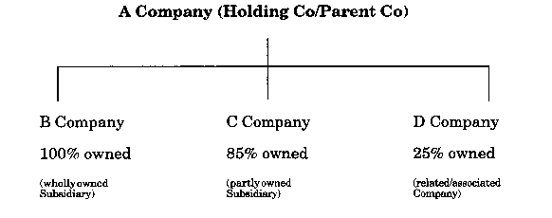

Holding/Parent Company

This is a company which exercises control over another company, its subsidiary.

Subsidiary Company

A company is a parent company in relation to another company, a subsidiary company, if:

a) It holds a majority of the voting rights in the company, (i.e. 51% of the ordinary shares) or

b) It is a member of the company and has the right to appoint or remove a majority of its board of directors, or

c) It has the right to exercise a dominant influence over the company -

(i) by virtue of provisions contained in the company's memorandum or articles, or

(ii) by virtue of a control contract, or

d) It is a member of the company and controls alone, pursuant to an agreement with other shareholders or members, a majority of the voting rights in the company.

Associated and Related Companies (including Joint Ventures)

Many people consider these two terms synonymous, but in reality there can be a subtle distinction. An associated company is defined as:

A company, not being a subsidiary of the investing group or company, in which:

a) The interest of the investing group is that of a partner in a joint venture or consortium and the investing group is in a position to exercise a significant influence over the company in which the investment is made.

b) The interest of the investing group is for the long term and is substantial and the investing group is in a position to exercise a significant influence over the company in which the investment is made.

For paragraph (b) above, substantial is taken to mean 20% or more of the equity voting rights of a company. If a company holds more than 20% of the voting share capital of another company, then the company in which the investment is made will be deemed to be an associated company unless it can clearly be demonstrated otherwise.

An associated company will always be a related company, but related companies are not associated companies, if the investing company:

a) Is not in a position to exercise significant influence and/or

b) Holds less than 20% of the equity voting rights.

Accounting Treatment of Subsidiaries and Associated Companies

Group accounts fully consolidate the results, assets and liabilities of all the subsidiaries within the group. Where a company is not wholly owned e.g. 15% is held by outsiders then that proportion of the subsidiary company's net assets is calculated and shown in the group balance sheet as 'minority interests’ or ‘outside equity interests’.

Associated Companies' results are not fully consolidated. However, in the group profit and loss account, the group's share of the associated company's pre-tax profit should be shown separately. If the parent company holds less than 20% of another company then it would only include the dividends receivable as Investment Income. The Group Balance Sheet will either show the associated company at valuation or at cost plus share of the associated company's post-acquisition retained profits and reserves.

The Profit and Loss Account / Income Statement

The Profit & Loss Account (P&L Account) summarises the income and expenses of a business for an accounting period. This can be a week or a month but is usually a year. It shows the tax charged against profit and the extent to which profit after tax is paid out to shareholders in dividends. Any profit after tax which is not paid in dividends is retained in the business.

A simple profit and loss account is shown overleaf, followed by an example which is laid out in the required format for published accounts. This latter example has additional complications as it relates to a group of companies and is the consolidated accounts for the group, not just a single company. The results of the single company are shown separately in the 2 right hand columns. Companies do not have to publish their detailed profit and loss account i.e. showing how much was spent on telephone, rates, motor expenses etc. but they are required to detail certain items whether on the face of the P & L or in the notes to the accounts. Items that must be shown include - interest, depreciation, staff costs, lease payments and auditor's remuneration.

Note that the Profit & Loss Account is called an Income Statement. This is an actual example drawn from Woolworths.

Profit and Loss Account

For the Year ended 30 June 2007
$'000 $'000

Sales 520
Less: Cost of Sales
Opening Stock 80
Purchases 350
430
Less Closing Stock 90
340

Gross Profit 180
Other Expenses:
Wages & Salaries 60
Motor expenses 6
Rent & Rates 16
Telephone 16
Electricity 8
Distribution 14
Provision for bad debts 4
Depreciation 10
Interest 6

140
Net Profit 40

The format shown above is one that will be used internally only.

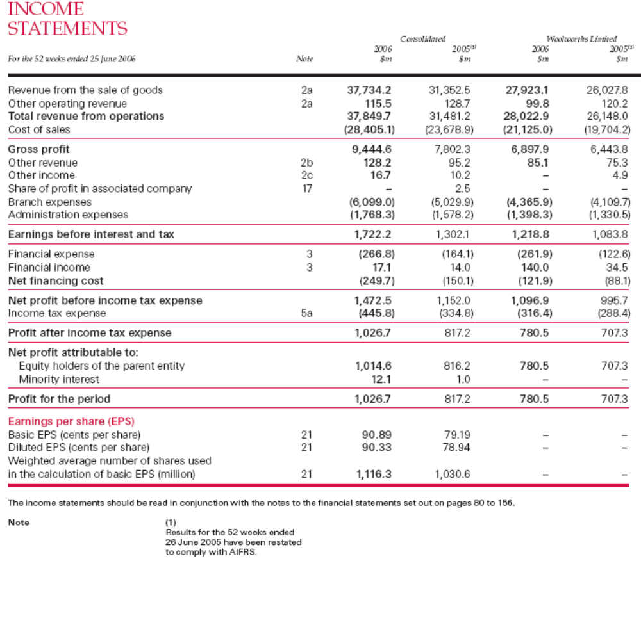

Revenue

Revenue is another name for sales. It excludes Goods and Service Tax (GST). Normally a sale is made when goods have been delivered or left the Company's premises or, for a service industry, when the service has been performed.

Companies are required to show in the notes the revenue and profit split between each category of business. They are also required to show a geographical analysis if they trade abroad.

Operating Expenses

Operating Expenses are all the expenses of the business (excluding interest which is shown separately), which have been incurred to achieve the stated revenue. A further breakdown is shown in the notes to the accounts (including wages and salaries).

Woolworth has classified these expenses between branch expenses and other.

Depreciation and Amortisation

The period charge for the use of certain assets, normally fixed asset, reflecting the reduction in their value. Depreciation can be determined as follows: (there are other methods of calculation)

COST - residual value
Expected useful life = period charge

The rates of depreciation are largely determined by the company and are disclosed in the notes to the accounts, although there are guidelines on what is reasonable, nevertheless, the expected useful life is a matter of judgement. Also there are set rates laid down by the Tax office and so many companies adopt these.

The accumulated depreciation is shown in the balance sheet as a reduction in the value of fixed assets.

Amortisation is another word for depreciation and is particularly applied to Intangible Assets, such as Goodwill or Leases.

Provision for Doubtful Debts

A sale is made when the goods leave the premises irrespective of when the customer pays. If one of the customers goes into liquidation and there is no chance of recovering the debt then the company writes the debt off as a bad debt thus reducing the company's profit.

Certain debts may be difficult to collect but would not yet be considered as bad. In these cases the company may set up a provision for doubtful debts. The provision may be specifically set up for certain customers or may be a general provision calculated at say 2% of total debtors. By calling a debt bad it removes the debt from the books of the company altogether. The provision retains the debts in the books but reduces the value of debtors as shown on the balance sheet and reduces the company's profit to the extent that the provision, if any, set up in previous years, is less than the current level.

Stock/Inventory Obsolescence

In order to calculate cost of sales (not to be confused with cost of selling) companies value their stock (or inventories) held at the year end at the lower of cost or net realisable value. The stock is physically counted at the year end and then each item is valued at the appropriate price generally on the basis of FIFO (first in first out) i.e. the latest price is applied to the stock. If some goods are obsolete or damaged and the value is lower than the cost price then the lower value is taken.

$'000

Opening stock 800
Purchases 4,800
5,600
Less closing stock 1,200

Cost of Sales 4,400

Determining the net realisable value of stock can be subjective. Some companies may well manage their results by over-valuing closing stock and by so doing reduce cost of sales and increase gross profit.

Share of Profits in Associated Company

Refer to page 6 for the accounting treatment of associated/related companies.

Earning before Interest and Tax (EBIT)

This is a commonly used measure of the efficiency of operational managers. It is the (net) profit after all operating expenses but before interest and tax.

Finance Expenses/Interest Payable

This is the interest charged for the year on any loans held by the company.
Financial Income/Interest Income is shown here. Often it is not shown separately on the face of the Income Statement but included under Revenue for Ordinary Activities, but the actual amount will be disclosed in the notes.

Income Tax Expense

Companies pay Income Tax on their income and Capital Gains. If there is overseas income then companies will also suffer overseas tax. All this appears under this heading.

GST, Excise Duty, employee PAYG and other forms of tax that a company may bear are not normally shown on the Income Statement (although they may affect the creditors on the Balance Sheet).

Net Profit attributable to Equity members of the Parent Entity

This figure represents the profit earned by the company from its ordinary activities.
The company will then determine how much of it is retained and how much it wishes to distribute in the way of Dividends. Dividends are no longer shown by most companies on the face of the Income Statement but as part of the note on Retained Profits/Earnings in the Balance Sheet.

The resulting retained profit for the year is added to the retained profit brought forward from previous years and is shown in the balance sheet as a source of income under the heading of Reserves or Retained Earnings/Profit

Net Profits Attributable to Minority Interests

The minority shareholders' share of post tax profits of the partially owned subsidiary. For example, Holding Company ('H'Ltd) owns 80% of 'S'Ltd.

'S' Ltd Minority Interest
$ $

Profit after tax 120,000 24,000

In Holding Company's Group Accounts

'H' Ltd
$

Profit after tax (including $120,000) 280,000
Less net profit attributable to outside equity interests 24,000
Profit attributable to members of the parent entity 256,000

Earnings per Share (E.P.S.)

This is calculated by reference to the profit attributable to members of the parent i.e. after deducting ordinary dividends due to minority interests and preference dividends, tax and extraordinary items, divided by the number of ordinary shares in issues.

It is one of the finance performance indicators used extensively by analysts when commenting on a company's performance.

Basic
This is calculated by dividing the profit by the number of shares currently issued.

Diluted
This is calculated using the same profit but dividing by all the shares that could be issued. Typically this relates to share options which have been granted but not exercised.

Statements of Recognised Income and Expense

This summarises all profits and losses whether they have been realised - in which case they are included in the Income Statement, or not – in which case they will be shown here. The most common items are:

- The reported profit which will be the same number as reported on the Income Statement
- Changes in accounting standards. Where a new accounting standard requires different accounting treatment and this has a significant effect on the results, then the effect will be shown here and the previous years figures will also be adjusted for consistency.
- Foreign exchange differences in holding values of overseas operations
- Changes in Revaluation Reserve. If a revaluation of non current assets has been carried out during the year, any surplus or deficit would be shown here – rather than included it as “normal” profit

The Balance Sheet

The Balance Sheet shows a company's financial position at a specific point in
time. It classifies items between:

Assets owned (= use of funds) and liabilities (= sources of funds)

On the following 2 pages you will find:
- A simple example of a Balance Sheet using the 'vertical' format which has superseded the old 'horizontal' format.
- An example of a Balance Sheet taken from a set of published accounts. This shows the consolidated position – in other words all the assets and liabilities of the Group and as well as just the Parent – shown as “the Company”.
- The example shown is from Woolworth Limited.

Balance Sheet as at 30 June 2007

$'000 $'000

Current Assets
Cash 30
Receivables 80
Inventory 90
200

Non-Current Assets
Investments 20
Property, plant & equipment 150
170

Total Assets 370
Current Liabilities
Payables 50
Tax 10
Provisions 10
70

Non-Current Liabilities
Long Term Loans 60

Total Liabilities 130

Net Assets $240

Equity
Equity 160
Reserves 30
Retained Profits 50
Total Equity $240
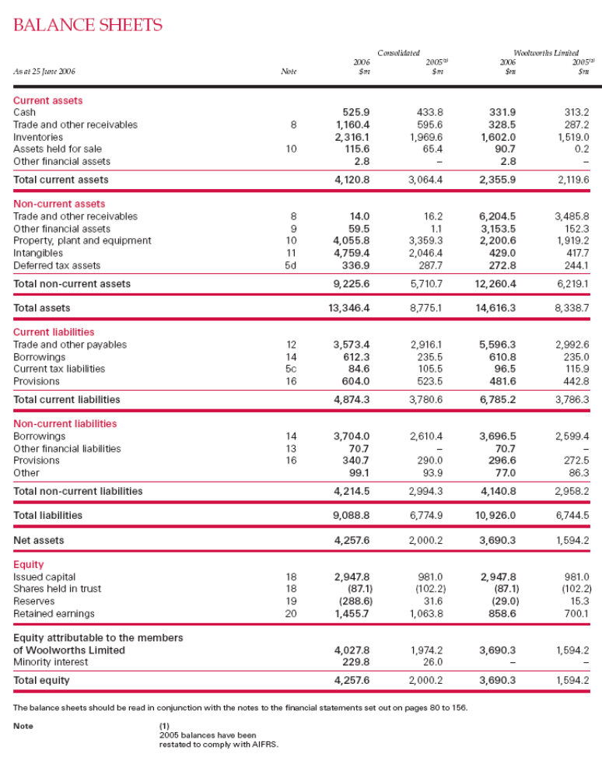

Current Assets – Receivables (Also known as Debtors)

Receivables shown on the face of the balance sheet may be one amalgamated figure to include trade receivables, other receivables, amounts owed by related companies and prepayments and accrued income. The split within each category will be shown in the notes.

Trade receivables represent money owed by customers as at the balance sheet date. The value will be net of bad debts i.e. customers who are not expected to pay and provisions for bad debts i.e. customers who are unlikely to pay. Companies may make a general provision e.g. 2% of all debts or specific provisions e.g. 50% of debt owed by company B. etc.

Prepayments represent items such as payments for rent and rates paid prior to the balance sheet date but which relate to the following accounting period.

Debtor Control

Commercial organisations normally give credit to their customers in order to encourage sales. In the case of a university, it is less likely that you will be giving credit to encourage sales (and hence revenue) and more likely that your commercial clients will want credit or dictate the terms on which they will pay. This may often be expressed in terms of, “we want this research done but we are only prepared to fund it for $X. Financially you may be better off walking away from the project in these circumstances – you cannot afford to run out of cash.

Debtor control is important in managing your cash. The more quickly you can collect cash, the more likely it is that you can cover your accounts payable, or use the money for other purposes. Generally speaking, the longer an account is outstanding, the less likely it is that a client will pay. Debts outstanding in excess of 90 days can be difficult to collect and this involves additional costs. Therefore, debtor control is quite important to the financial health of the university. It is better to have cash in your account than in your client’s account.

If stage payments are delayed, you may have to say the research cannot be completed until payment is made – this is an effective negotiating tactic with many commercial organisations.

So what should you be aiming at in terms of debtor control? The key objective is to get your cash in the shortest possible time. It is ideal if you are paid before you provide the service. However, if you agree to terms for payment once the service has been provided, (for example within 30 days), you should try to collect the money as soon as possible to this date.

Commercial organisations will often delay paying you for as long as they can because it helps their cash flow. You, in effect are funding their business at the expense of your own. A general rule of thumb is Agreed time plus 33%. If your debtors are exceeding this rule of thumb it is time to take prompt action.

How can you exercise prudent debtor control? The following procedures will help:
- Send invoices promptly – the quicker invoices are sent, the quicker they are paid. The best time to send invoices is at completion of the service. Don’t wait until the end of the month as this automatically gives the customer more time to pay. It is also useful to know the invoice payment cycle of your client – if they process invoices before the 30th
- Send statements monthly as this reminds clients to pay.
- Phone the client – in a research environment, it is wise to have the head researcher make this call as he/she will have a relationship with the client and this relationship is a powerful tactic in negotiating payment
- Send a reminder letter

Hopefully you will not be involved in the collection of bad debts. If you find that a client will not pay fir your services, contact FiRM, because there may be a need for legal action to be taken.

Current Assets - Inventories (Also known as Stock)

Inventories may be valued at the lower of cost or net realisable value i.e. if the stock is obsolete or damaged it should be written down to the value that it can be sold for provided of course that the value is below cost. What is cost?

Cost is not just the purchase price of the raw materials. It should include import duty, transport and handling costs and any other directly attributable costs as well as costs of conversion e.g. direct labour, direct expenses, appropriate production overheads and other overheads, if any, attributed to bringing the product or service to its present location and condition.

From this loose definition of cost it is obvious that companies have considerable flexibility as to how they value their stocks. In the first year they can suit themselves but in later years they must remember the consistency concept. Companies cannot keep changing their method of valuation. If they do change the method and this results in a material difference in the valuation they must include a note in the accounts to highlight the effect of the change.

Companies are required to show the value of their inventory split between raw materials, work in progress and finished goods.

Investments

Investments are generally shown under the heading of non-current assets. However, investments which will be sold within a year can be shown in current assets. Investments will be classified between related (associated companies) and other investments and for each of these headings the notes will detail the amount of the investment in quoted and unquoted companies.
The value of the investment may be included at cost or market value. The notes will specify the market value if the investments have been included in the balance sheet at cost.

Non-Current Assets (also known as Fixed Assets) - Tangible Assets

The definition of non-current assets is long term assets not held for resale in the normal course of business but for the purpose directly or indirectly of earning revenue.

If a company was to purchase a motor vehicle it would be unreasonable to charge the cost of that asset against the profits for the year in which the asset was purchased because the motor vehicle would still be used in the following year and indirectly contributing to future revenue. The charge for the decreasing 'values' of the motor vehicle is 'depreciation'. (Value, in this context, does not mean resale value).

The detail of the non - current assets will be explained in the notes to the accounts i.e. the value of property leasehold and freehold, plant and machinery, fixtures and fittings and motor vehicles. The notes show the cost at the beginning of the year, additions and disposals during the year and the cost at the end of the year. The depreciation is also shown for each heading and the figure shown on the face of the balance sheet is the cost of assets owned at the end of the year less the accumulated depreciation i.e. the 'net book value'.

Several companies revalue their assets, especially property; in this case the notes will show the value of assets recorded at cost and the value of assets at valuation with the date of the valuation. You will see in the Accounting Policies notes whether the company carries out regular revaluations – a typical period is every 3 years. There is no legal requirement to revalue assets. Where they have been revalued, A- IFRS requires companies to carry out annual revaluations to prove the amount. They must have been valued independently and the name of the valuer must be shown in the notes in the year of revaluation. Adjustments are shown in a Revaluation Reserve which is shown as part of Reserves in the Balance Sheet.

Non-Current Assets (also known as Fixed Assets) - Intangible Assets

By definition, these are assets which have no physical existence. Items that are considered to be in this category are goodwill, patents, trade marks, copyrights, brands, etc.
Goodwill arises when one company takes over another company and pays more than the value attributed to the net assets. Goodwill is therefore the excess of the purchase price over the value of the net assets of the company that is acquired.

Companies are now required to prove the carrying value of intangible assets or write them off (called amortisation). The way this is done is by projecting the future earnings that will be generated by the intangible asset and then discounting those earnings to present value using a technique called Discounted Cash Flow. This is a highly subjective area and analysts tend to add back amortisation of goodwill when considering a company’s results.
.

For other intangibles such as Brands, the same calculation needs to be made to ensure that the value of brands is not overstated – again the Accounting Policy note will set out how the asset has been treated.

Current Liabilities – Payables (Also known as Creditors)

Like receivables, the payables figure will usually include all payables and the split will be shown in the notes. Payables will include such items as:

Bank overdraft/loans
Trade creditors
Other creditors
Taxation
Dividends payable
Accruals and deferred income

All payables shown under current liabilities are those that are payable within one year.

Accruals represent items for which invoices have not been received but expenses
have been incurred e.g. telephone, electricity and gas. A company with a year end on 31 December may receive a quarterly telephone bill up to 31 January in the following year, covering the three months to 31 January. The company would then estimate the telephone charge for November and December and include that amount as a charge against profits and as an accrued expense in the balance sheet.

Non-Current Liabilities (Payables due after more than one year)

This heading will include the following:

Interest Bearing Liabilities
Deferred Tax Liabilities
Provisions
Obligations under finance leases

Interest Bearing Liabilities

Under this heading will be shown Bank Loans, Other Loans and companies are required to show the rates of interest, the redemption dates and the security given for the loans – where applicable.

Lease Liabilities

A lease is a contract between lessor and a lessee for the hire of a specific asset.
The lessor retains ownership of the asset but conveys the right to the use of the
asset to the lessee for an agreed period of time in return for specified payments.
Leases can be classified into operating leases and finance leases.

An operating lease involves the lessee paying a rental for the hire of an asset for a period of time which is normally substantially less than its useful economic life. The lessor retains most of the risks and rewards of ownership of an asset.

A finance lease usually involves payment by a lessee to a lessor of the full cost of the asset together with a return on the finance provided by the lessor. The lessee has substantially all the risks and rewards associated with the ownership of an asset other than the legal title. In practice, all leases transfer some of the risks and rewards of ownership, the distinction between a finance lease and an operating lease is essentially one of degree.

Where companies have acquired assets under a finance lease they should be shown on the balance sheet as fixed assets and the obligations to make future payments should be included within current liabilities or long term liabilities.

Under an operating lease companies only account for the rental charges through the profit and loss account. The asset and the liabilities will not appear on the balance sheet.

Most hire purchase contracts are considered to be finance leases and should be treated in the same manner.

Deferred Tax Liabilities

The amount of tax payable on profits of a particular period often bears little relationship to the profit appearing in the financial statements. This results from the different basis on which profits are arrived at for the purpose of tax computations as opposed to the basis on which profits are stated in the financial statements.

The reasons are that certain types of income are tax free and certain types of expenditure are disallowable e.g. Entertaining, and fines. This gives rise to 'permanent differences'. Secondly, certain items that are included in the financial statements in one period will be accounted for tax purposes in a different period thus giving rise to 'timing differences'. A number of timing differences arise from the use of receipts and payments basis for tax purposes and the accruals basis in financial statements e.g.

Interest receivable - taxed when received
Provision for repairs and maintenance - taxed when expenditure is incurred

Timing differences might also arise due to difference between the depreciation rate allowed by the ATO and the company's chosen depreciation rate.

Companies are required to account for the difference in their actual tax liability and the liability based on profits, to the extent that these differences arise from timing differences and are likely to crystallise at a future date.

Provisions

Defined as any amount retained to provide for any liability or loss which is either likely to be incurred or certain to be incurred but uncertain as to the amount or as to the date on which it will arise. Provisions may be set up for such things as warranty claims on products or the future cost of closing a factory.

Determining the amount of any provision is very much at the discretion of the directors. The auditors have to satisfy themselves that the amount is reasonable but beyond that the company's profit can be adjusted by use of provisions to suit the directors' purpose.

Contributed Equity or Share Capital - Authorised and Issued Share Capital

When a company is formed the authorised share capital and nominal value (i.e. $2, $1.00, .50c, .10c, shares etc.) are established and written into the company's Memorandum of Association. The directors cannot issue new shares in excess of the authorised limits without the approval of the shareholders to increase the authorised limit.

The issued share capital is the nominal value of all the shares that have been issued. e.g. 10,000 shares at $1.00 gives a nominal value of $10,000.

Ordinary Shares

These usually form the bulk of the share capital of a company. Ordinary shareholders are normally entitled to all the profits remaining after the tax and dividends paid to holders of preference shares although it is highly unlikely that all the remaining profits will be distributed. Ordinary shareholders are entitled to vote at a general meeting giving them control over the election of directors.
A company may purchase its own shares provided it does not buy in all its non- redeemable shares. Each contract for purchases outside the normal market must be authorised in advance. General authority may be given for market purchases up to a maximum number of shares within a given price range and within 18 months from the date the resolution is passed.

If companies buy back their shares at a price below asset value they then increase the asset value of the remaining shares.

Reserves/ Retained Profits/Earnings

There are several different headings for reserves, the most common being accumulated profit or retained profit; this is the profit that the company has made net of losses since its incorporation that has been retained in the business i.e. not paid out as dividends.

Revaluation Reserve

This is a separate classification used for the surplus or shortfall on the revaluation of assets. This is also described under Non Current Assets above.

Cash Flow Statements

This shows how cash has flowed in and out of the organisation during the year and is not to be confused with a cash flow forecast described at the end of this document.

The Cash Flow Statement highlights the net cash inflow or outflow from:
- Operating activities (i.e. the main trade of the company),
- Financing activities (i.e. changes in the way the company is financed) and
- Investing activities (i.e. changes in fixed assets).

From these three separate classifications it is possible to see whether the main trade of the company (the operating activities) is generating cash or using it up.

Investing activities are long term and will typically include the purchase of fixed assets, so if a company is investing in the future this is likely to be a net cash outflow. To what extent is the company putting money in to long-term assets?

Finally, financing shows how these activities have been financed.

The three main cash flows are then totalled and added or deducted from the opening cash/bank balances to determine the closing position. These numbers should therefore reconcile to the cash/bank figures shown on the Balance Sheet.

An example of a company's cash flow statement is shown overleaf. The format is not likely to differ that much between that for a single company or a group of companies.

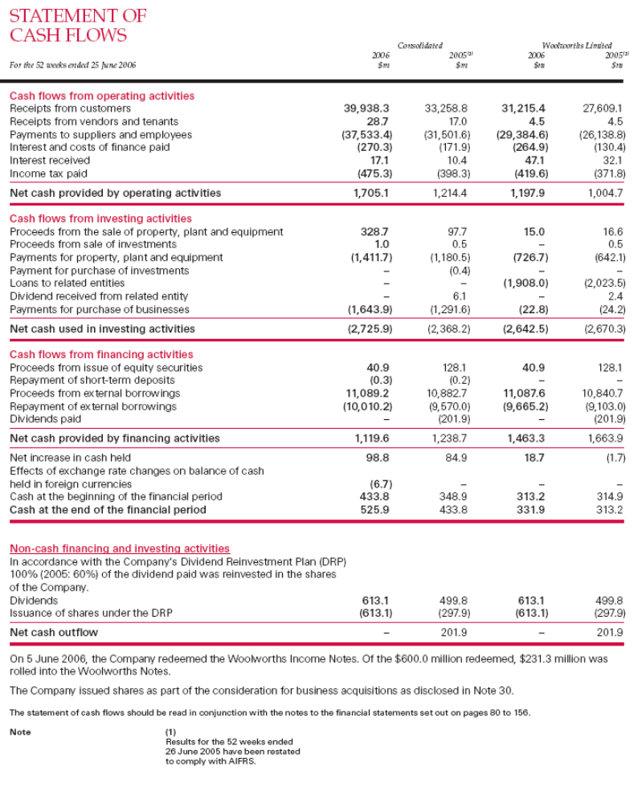

Cash Flow Forecasts

Cash flow forecasts are a vital element of the budgeting process, for when all the operating budgets have been prepared and consolidated into a company budget the financial implications of the budget can be assessed. This is an internal document, not part of financial reporting. It is however a vital part of good financial management of a company.

The cash flow forecast will usually be prepared on a computer spreadsheet and will look like the example shown below:

$'000
Receipts Jan Feb Mar Apr May June
Sales 80 20 40 60 80 100
Loan 100
Sale of Assets 20
80 120 60 60 80 100

Payments
Materials 40 10 20 30 40 50
Salaries 16 16 16 18 18 18
Rates 40
Fixed Assets 110
GST 16 8
56 42 146 48 106 68
Net Cash Flow 24 78 (86) 12 (26) 32
Opening Balance 8 32 110 24 36 10
Closing Balance 32 110 24 36 10 42

Note: The opening balance will be the Company's cash book balance as at 31
December.

By scheduling the cash inflows and outflows month by month it is simple to see if there is likely to be a cash flow problem. If so there are 3 alternatives:

1) Arrange for financing to be available when required

2) Reschedule expenditure

3) Revise the budget to meet the cash constraints

The receipts are estimated from the sales forecast based on the time customers
normally take to pay e.g. assuming customers take 60 days to pay; the receipts in
January will represent November's credit sales + GST. Sales of course exclude
GST but the customer will pay the total of the invoice including GST.

The loan and sale of assets are recorded in the month they are scheduled to be received.

Materials are estimated on the same principle as that for receipts. Salaries remain constant until there is a salary rise.
The Company pays $80,000 in rates 1/2 in May and 1/2 in November hence the $40,000 outgoing in May. If this caused a cash flow problem it would be sensible to pay on a monthly basis irrespective of any possible finance charge.

Likewise a payment for fixed assets can be easily rescheduled by negotiation or delaying the purchase, however, this could effect the production and sales budget resulting in the budget process having to be done again.

The GST is paid quarterly and will be calculated by deducting the GST on the purchases from the GST on the sales.

There will be many other items of expenditure which have not been shown in the above example.

